Ideation Phase
Brainstorming- Idea Generation
Date | November 2, 2025
Team ID | F53C03230D9D3649CD4402B24FF15FEB
project Name | Educational organization using ServiceNow

Project: Educational Management System Using ServiceNow
Objective: To capture all initial ideas for streamlining administrative tasks in an educational organization.
Mind Map / Idea List:
- Central Idea: Educational Management System
  - Pain Points:
    - Manual data entry is slow and error-prone.
    - Tracking student progress is difficult (spreadsheets, paper files).
    - Admission process is cumbersome and hard to track.
    - No central location for student data.
  - Key Users:
    - School Administrators
    - Teachers
    - Admissions Officers
  - Core Modules:
    - Student Admissions:
      - Online application form.
      - Track admission status (New, In Progress, Rejected, Joined).
      - Auto-generate a unique Student ID.
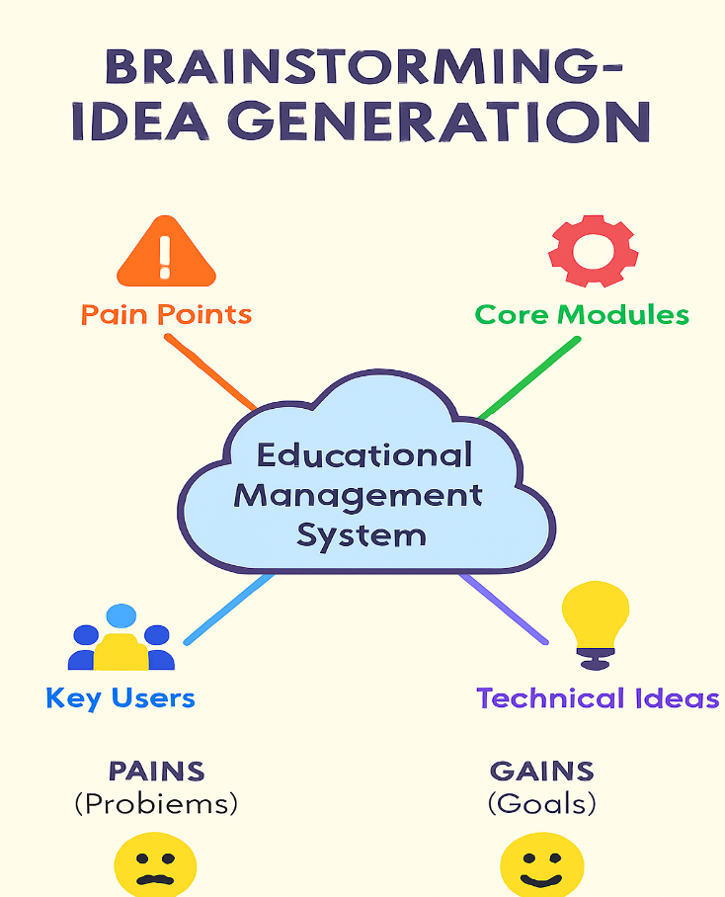
    - Student Progress Tracking:
      - Record marks for different subjects (Maths, Science, English, etc.).
      - Automatically calculate Total, Percentage, and Pass/Fail Result.
      - Link progress report to a specific student.
    - Student Data Management:
      - Central table for all student details (Name, Father's Name, Address).
      - Ability to see all related data (admissions, progress) in one place.

  - Technical Ideas (How to build in ServiceNow):
    - Use custom tables for Admissions and Progress.
    - Use a "parent" table to hold common data (like Student Name).
    - Use Client Scripts for auto-calculations (Total, Percentage).
    - Use Client Scripts to auto-populate data (like Pincode -> City/District).
    - Use Form Design to make forms easy to read (sections, 2-columns).
    - Use a Process Flow bar on the Admission form to show the status.

